Message Format
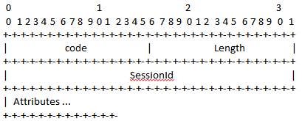
Operation Code:
-1 Connect
-2 Connect ACK
-3 Connect NAK
-4 Disconnect
-5 Get Request
-6 Set Request
-7 Accept Response
-8 Reject Response
Length:

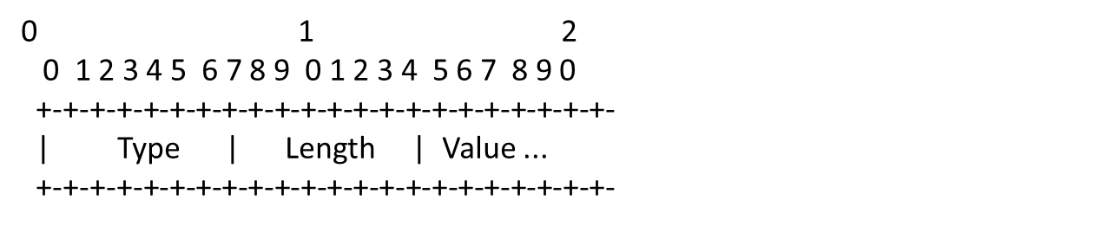
Type:
Length:
Value:

Attribute
- User Name(STRING)
- Password(STRING)
- Reply-Message(STRING)
- Attribute-List(UINT8LIST)
- activeApplicationList(UINT8LIST)
- sysDescription(STRING)
- sysName(STRING)
- sysObjectID(STRING)
- sysLocation(STRING)
- sysContact(STRING)
- rebootReason(STRING)
- rebootTime(UINT32)
- softwareVer(STRING)
- serialNum(STRING)
- vendorType(STRING)
- physDescr(STRING)

Procedures

Connect
The connect request includes username and password.
If the username and the password are correct, collectd creates a session, start a session timeout timer and setup the user plane. Collectd replies with Connect ACK. A new Session ID is filled into Connect ACK. Session ID is a random number.
If the username and the password are not correct, collectd replies with Connect NAK (Reply-Message is set)

Get MibDevice
PPM sends “Get Request” which includes Attribute-List. The Session ID is included in “Get Request”.
If the session is inactive, collectd will reply with Reject Response (Reply-Message is set).
If the session is active, the timeout timer will be reset for the matching session. Collectd will reply with Accept Response. If some attributes are not supported, collectd will skip these attributes. PPM will fill with the default value.

Get MibNode
PPM sends “Get Request” which includes Attribute-List. The Session ID is included in “Get Request”.
If the session is inactive, collectd will reply with Reject Response (Reply-Message is set).
If the session is active, the timeout timer will be reset for the matching session. Collectd will reply with Accept Response. If some attributes are not supported, collectd will skip these attributes. PPM will fill with the default value.

Get Capability
Similar to the above scenario.

Disconnect(Delete Node/Unmanage Node)
If PPM calls “delete Node” or “Unmanage Node”, PPM will send Disconnect message.
Collectd will remove the session, stop the timeout timer and clean the user plane setting.

Remove Inactive Session
A timeout timer is started for each session. If the timer is timeout, the session and the user plane will be cleared.

